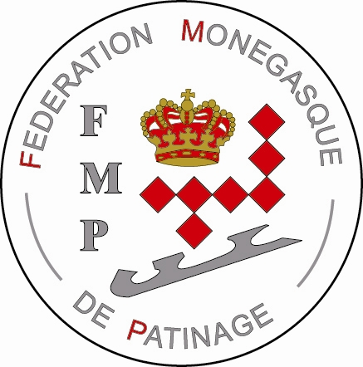
Th

Monaco, may 27th 2008

INVITATION TO PARTICIPATE IN THE 4th INTERNATIONAL ICE HOCKEY “PEE-WEE” TOURNAMENT IN MONACO
From Tuesday December 30th 2008 to Sunday January 4th 2009

Dear Ice Hockey Presidents and Managers,
The Monegasque Ice Skating Federation (FMP) is pleased to invite you to participate in the 4th International Ice Hockey “Pee-Wee” Tournament in the Principality of Monaco to take place this year from Tuesday December 30th 2008 18.00hr and end on sunday january 4th 2009 at about 1h30 pm. To be followed by the closing ceremony, where will be served a buffet.
There is no entry fee for the tournament. However you are asked to put a deposit of 350 Euros will be either returned or used against lodging costs.
The registration and list of players is to be sent by e-mail to Bruno Catelin (bcatelin@yahoo.fr) who has taken on the responsibility for the sporting event and the coordination of the tournament. The original list and the deposit check are to be sent to : Joseph Zorgniotti, Secretary General of the Federation, Stadium Louis II, 7 avenue des Castelans, 98000 MC Monaco. The first 8 teams to respond with application form and deposit will be elected to participate in the tournament.
The desd line for registering is august 31st 2008.
The Games will be played in 2 x 18 min. periods stop time. In the first stage, all the teams will play once against the others. The second stage, teams finishing 1 to 4 will play in a semi final and final. The remaining 4 teams will play in a classification game.
It is recommended to have 3 lines of 4 players plus one or two goalkeepers. The maximum is 4 lines (16+2GK) and the minimum is 2 lines of 4 ( 8+1GK). Please submit the list of players as early as possible in order to have the programs printed.
There will be no lending (or borrowing) of players to other teams.
However teams can be made up of players from different home clubs.
For the players lodging , we could organise this by placing everyone in vacation centers The lodging including meals will be about 50 Euros per day and per person. Other lodging for parents are also available and we will help finding the appropriate hotels if required.
Thank’s for sending the registration entry form no later than august 31st 2008.
In the hope of seeing your participate in this unique and wonderful chance in a life time tournament, we remain at your disposal.
Till we hear from you, please accept dear ice hockey President and Managers, our very best wishes.
For the President on the Moncao Ice Skating Federation
The Delegate in charge of the Competition
Bruno CATELIN
Encl.: Registration Entry Form
For additional information, please email : bcatelin@yahoo.fr
P.S. : The Best Trophy goes to the team with the best « Fair-Play » record .

